Automated Folder and Cut File Creation

New Surrey

Document Approval
Approver | Approved Date | Rejected Date | Comments
Kuldip Sidhu
Baljot Kandola

Part 1 Functionality Overview
Objectives
New Surrey would like Orderstream to automatically create machine files based on the configurator setup/selection and put these machine files on their shared drive within an existing folder structure.
Existing Workflow: Currently New Surrey clicks a button in their excel configurator(highlighted below) which creates the necessary machine files and puts these files on their shared drive into the correct folder. We are looking to replicate and automate this process with our sales order/configurator.
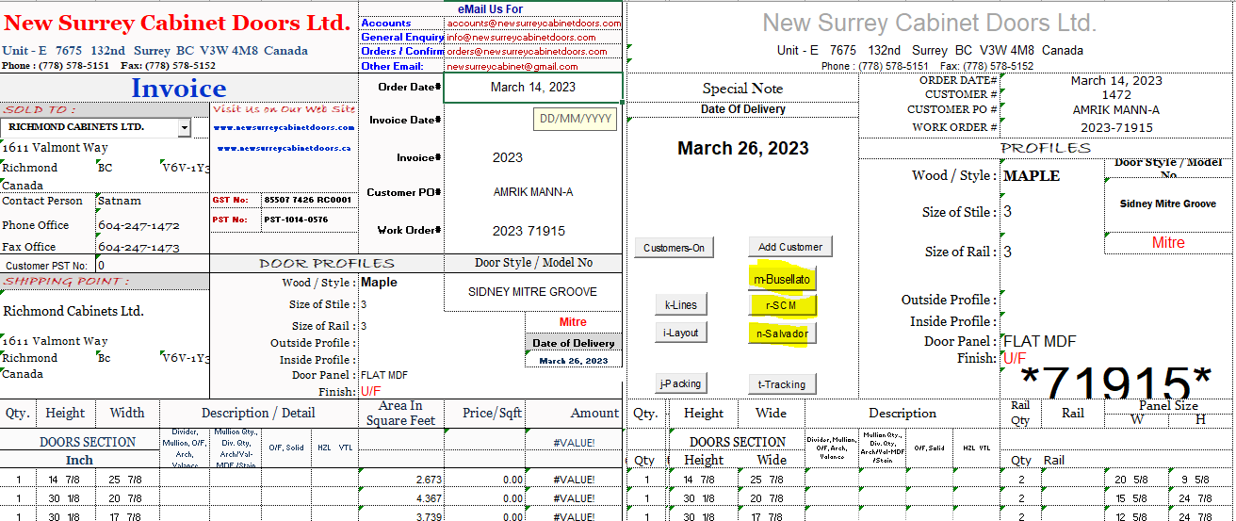
Proposed Solution: When the Sales Order is processed in the quick config screen, the machine files are created and dropped into the appropriate folder on the shared drive.
The user has created a SO with a configured item and is using the quick config to add a configured item to the order. When the user clicks “process” in the quick config screen, the machine file is created and dropped into one of the below listed folders:
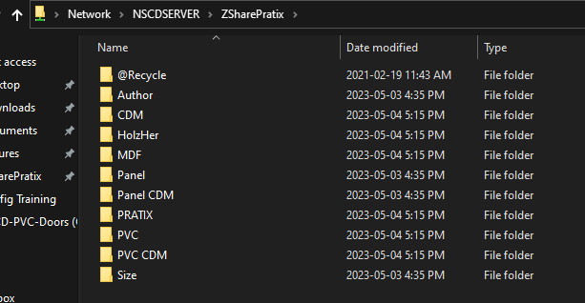
They have provided examples of the files required for their machines. All files we create would need to be named after the Sales Order# and machine type(see below examples).

The determining factor of what files need to be created and what folder they go into is based off of the configurator inputs. Below are the parameters for each of the different product types:
Product Type = Wood
The files with the Door Cut Sizes would go to 2 folders:
ZShareBusellato folder named as SO# and
ZSharePratix Author folder named as SO#
In addition if under Door Panel anything other than Flat is selected then the measurements for the Door Panels go to 3 folders - ZSharePratix Panel CDM folder named as SO#_Panel and Panel named as SO#_Panel
For wood doors with panels they would have 5 files created and dropped into the above folders.
Question: I can only see 3 files here.
if the product is wood - they need a door size regardless of anything else - door size goes to zsharebusselato and zsharepratix
Door Panel = Flat goes on the table saw only, no door panel files required.
Product Type= PVC
The files with the Door Cut Sizes would go to 3 folders:
ZSharePratix
CDM folder named as SO#_CDM
HolzHer folder named as SO#_HH.mzkord
PRATIX folder named as SO#_TIX
In addition, the Panel measurement that goes in between the PVC doors goes to 2 folders:
ZSharePratix PVC folder named as SO#_PVC
PVC CDM folder named as SO#_PVC.
The values of the panel measurements is going to the output values in the config UDF 9-17
For PVC doors(all have panels) they would have 5 files created and dropped into the above folders.
Product Type= MDF MLM and Acrylic
The files with Door Cut Sizes would go to 3 folders:
ZSharePratix CDM folder named as SO#_CDM
HolzHER folder named as SO#_HH.mzkord
PRATIX folder named as SO#_TIX.
There are no interior panels for MDF and Acrylic doors. A total of 3 files would be created and dropped into the above folders.
Any doors with Frames will require an additional file with the sizes to go to the
ZSharePratix Author folder named as SO#_FRAME.
Frames are found under property type Frame – it will have 0/F in this property, and have the same height and width sizes in the child config property.
Doors with config input on for hinge holes
If the option is YES – add the height, qty and width to the cut file ZSharePratix Author as SO#_HOLES this applies to all types of doors.
All machine files would contain information about the height, width and quantity of the doors to be manufactured based on the parent/child configurator inputs.
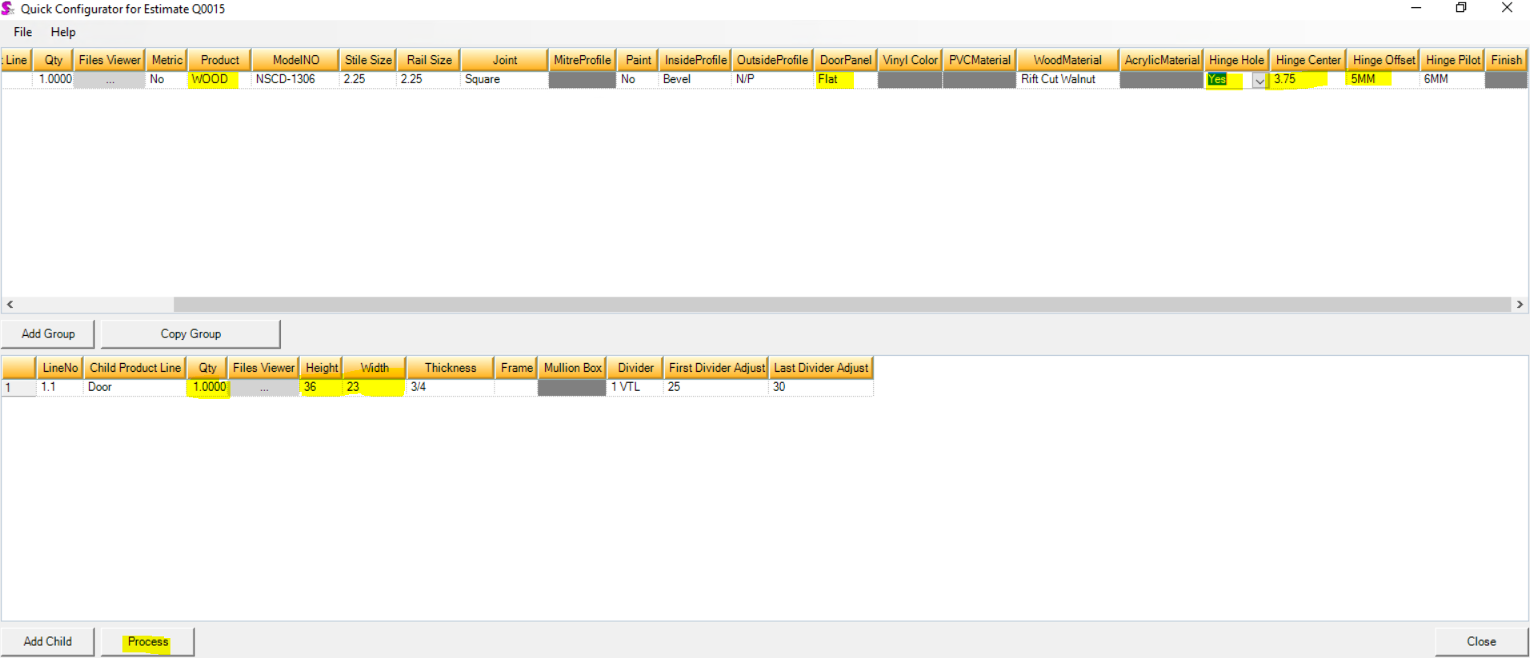
They would like the following to occur(if possible):
- If the configured SO is changed and the SO has been processed, a new file would be created and the old file(s) deleted.
- If the SO Line is deleted, the file(s) would be deleted.
- If the SO is deleted – the file(s) would be deleted
- If the file is older than 60 days the file(s) would be deleted.

*Number of User Defined Fields to Import*-----> |  | 99
UserDefined1 | Width | 14.875
UserDefined2 | Height | 44.875
UserDefined3 | Quantity | 1
UserDefined4 | Sqrft | 4.636
UserDefined5 | Hinge Hole | Yes
UserDefined6 | Hinge Hole Center | 0.75
UserDefined7 | Hinge Hole Offset | 0
UserDefined8 | Hinge Hole Pilot | 0
UserDefined9 | First Panel Height
UserDefined10 | First Panel Wide
UserDefined11 | Second Panel Height
UserDefined12 | Second Panel Wide
UserDefined13 | Third Panel Height
UserDefined14 | Third Panel Wide
UserDefined15 | First Panel Quantity
UserDefined16 | Second Panel Quantity
UserDefined17 | Third Panel Quantity
UserDefined18 | Linear Feet | 10
UserDefined19 | Model NO | Slab
UserDefined20 | Stile Size | 3
UserDefined21 | Rail Size | 3
UserDefined22 | Inside Profile
UserDefined23 | Outside Profile
UserDefined24 | Door Panel
UserDefined25 | Joint
UserDefined26 | Material | MDF 7035
UserDefined27 | Paint | No
UserDefined28 | Thickness | 0.75
UserDefined29 | Frame | O/F
UserDefined30 | Mullion Box
UserDefined31 | Finish
UserDefined32 | Vinyl Colour
UserDefined33 | Mullion Box Length
UserDefined34 | Mullion Box Width
UserDefined35 | Price/Sqrft | #N/A
UserDefined36
UserDefined37
UserDefined38
UserDefined39
UserDefined40
UserDefined41
UserDefined42
UserDefined43
UserDefined44
UserDefined45
UserDefined46
UserDefined47
UserDefined48
UserDefined49
UserDefined50
UserDefined51
UserDefined52
UserDefined53
UserDefined54
UserDefined55
UserDefined56
UserDefined57
UserDefined58
UserDefined59
UserDefined60
UserDefined61
UserDefined62 | Product Type | WOOD
UserDefined63 | Wood Products
UserDefined64 | Busellato Door Cut Sizes Folder | D:\Clients\New Surrey\CutListFiles\ZShareBusellato\
UserDefined65 | Busellato Door Cut Sizes File Name | SO2307002
UserDefined66 | Pratix Author Door Cut Sizes Folder | D:\Clients\New Surrey\CutListFiles\ZSharePratixAuthor\
UserDefined67 | Pratix Author Door Cut Sizes File Name | SO2307002
UserDefined68 | Pratix Panel Door Cut Sizes Folder | D:\Clients\New Surrey\CutListFiles\ZSharePratixPanel\CDM\
UserDefined69 | Pratix Panel Door Cut Sizes File Name | SO2307002_Panel
UserDefined70 | Pvc Products
UserDefined71 | Pratix CDM PVC Door Cut Sizes Folder
UserDefined72 | Pratix CDM PVC Door Cut Sizes File Name
UserDefined73 | HolzHer PVC Door Cut Sizes Folder
UserDefined74 | HolzHer PVC Door Cut Sizes File Name
UserDefined75 | Pratix PVC Door Cut Sizes Folder
UserDefined76 | Pratix PVC Door Cut Sizes File Name
UserDefined77 | Pvc Panel Sizes
UserDefined78 | PVC Panel Sizes Folder 1
UserDefined79 | PVC Panel Sizes File 1 Name
UserDefined80 | PVC Panel Sizes Folder 2
UserDefined81 | PVC Panel Sizes File 2 Name
UserDefined82 | Acrylic, MDF, MLM
UserDefined83
UserDefined84
UserDefined85
UserDefined86
UserDefined87
UserDefined88
UserDefined89 | Frame
UserDefined90 | Frame Door Cut Sizes Folder | D:\Clients\New Surrey\CutListFiles\ZSharePratix Author\
UserDefined91 | Frame Door Cut Sizes File Name | SO2307002_Frame
UserDefined92 | Hinge Holes
UserDefined93 | Hinge Holes Sizes Folder | D:\Clients\New Surrey\CutListFiles\ZSharePratix Author\
UserDefined94 | Hinge Holes Sizes File Name | SO2307002_Holes
UserDefined95 | Height | 44.875
UserDefined96 | Width | 44.875
UserDefined97 | Qty | 1
UserDefined98
UserDefined99

Appropriately, No.

